Dynamic memory allocation

Memory layout of a C Program

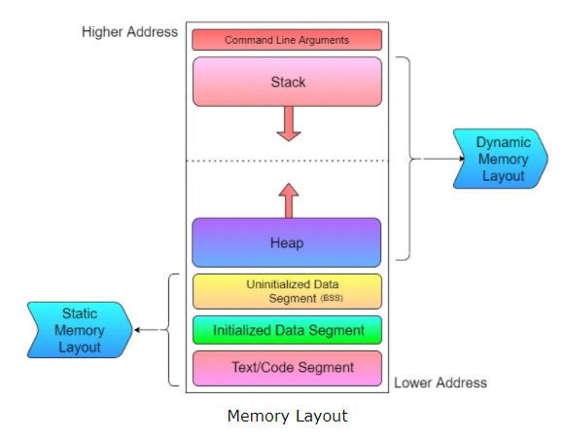

MALLOC:- (Allocating single block)

Description

A block of memory may be allocated using the function malloc. The malloc function reserves a block of memory of specified size and returns a pointer of type void, i.e. C library function void *malloc(byte-size) allocates the requested memory block and returns a pointer to it.

Declaration
Following is the declaration for malloc() function.
void *malloc(byte-size)

Parameters
- byte-size -- This is the size of the memory block, in bytes.

Return Value
This function returns a pointer to the allocated memory, or NULL if the request fails.
For example, It takes the following form:
ptr = (cast-type *) malloc(byte-size)
where ptr is a pointer of cast-type.

CALLOC:- (Allocating multiple blocks of memory)

Description

calloc is another memory allocation function that is normally used for requesting memory space at runtime for storing derived data types such as array and structures. While malloc allocates a single block of storage space, calloc allocates multiple blocks of storage, each of same size, and then set all bytes to zero.

Declaration
Following is the declaration for calloc() function.
void *calloc(n, elem-size)

Parameters
- n -- This is the number of contiguous block to be allocated.
- elem-size -- This is the size of each block.

Return Value
This function returns a pointer to the allocated memory, or NULL if the request fails.

Example
The following example shows the usage of calloc() function.
#include <stdio.h>
#include <stdlib.h>

int main()
{
int i, n;
int *a;

printf("Number of elements to be entered:");
scanf("%d",&n);

a = (int*)calloc(n, sizeof(int));
printf("Enter %d numbers:\n",n);
for( i=0 ; i < n ; i++ )
{
scanf("%d",&a[i]);
}

printf("The numbers entered are: ");
for( i=0 ; i < n ; i++ )
{
printf("%d ",a[i]);
}
free( a );

return(0);
}

Let us compile and run the above program that will produce the following result:
Number of elements to be entered:3
Enter 3 numbers:
22
55
14
The numbers entered are: 22 55 14

REALLOC:- (Altering the size of a block)

Description
The C library function void *realloc(void *ptr, newsize) attempts to resize the memory block pointed to by the pointer variable ptr that was previously allocated with a call to malloc or calloc.

Declaration
Following is the declaration for realloc() function.
void *realloc(void *ptr, newsize)

For example, if the original allocation is done by the statement

ptr= malloc(size);

then the reallocation of space may be done by the statement

ptr = realloc(ptr, newsize);

Example
The following example shows the usage of malloc() function.
#include <stdio.h>
#include <stdlib.h>

int main()
{
char *str;

/* Initial memory allocation */
str = (char *) malloc(15);
strcpy(str, "tutorialspoint");
printf("String = %s, Address = %u\n", str, str);

/* Reallocating memory */
str = (char *) realloc(str, 25);
strcat(str, ".com");
printf("String = %s, Address = %u\n", str, str);

free(str);

return(0);
}
Let us compile and run the above program that will produce the following result:
String = tutorialspoint, Address = 355090448
String = tutorialspoint.com, Address = 355090448

FREE:-

Description
The C library function free deallocates the memory previously allocated by a call to calloc, malloc, or realloc.

Declaration
Following is the declaration for free() function.
free(ptr)

